# Web 3 Practical – Forms

1. Write a JavaScript script that checks the content of the email input in the html form upon the user clicking the submit button. If the email entered is invalid, an error message is output to the span element in the HTML as illustrated in the following figure and the submit event default behavior is canceled.

Hint: research online the usefulness of the email.validity.valid property for an input element of type email.

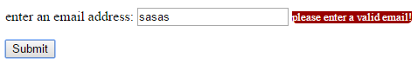

1. Study the p2.html file. It contains an HTML form. Create a function in JavaScript that validates that each of the 4 input sections have been input by the user. You don’t need sophisticated form validation here, just check that the user enters a name (any name), chose a gender, chose an age and agreed with the terms and conditions by clicking on the checkbox. Create your functionality step-by-step. If the user has input data correctly, you should inject a message in the div element with id=output in the HTML file, greeting the user by their entered name. Hint: the preventDefault() method of the event object might come in handy for this exercise.
2. C:\Users\drozado\Dropbox\Work\Teaching\IN712 - Web Programming 3\difficultyIcon.pngCreate a script that displays the local time (var now) and a remote time (var timeElsewhere) for one of the cities selected from the list. You should use the values attributes in the option HTML element to add or substract the corresponding offset in minutes from the 0 offset standard in London. The time for Daylight Savings option (var dstAdjust) should add 60 minutes of offset to the calculated time (var timeElsewhere). The following snippet might help you figure out the solution:

**var** now **=** **new** Date**();**

**document.**getElementById**(**"spanLocalTime"**).**innerHTML **=** now**.**toLocaleString**();**

**var** timeElsewhere **=** now**;**

timeElsewhere**.**setMinutes**(**now**.**getMinutes**()** **+** now**.**getTimezoneOffset**()** **+**

**parseInt(**offset**,** 10**)** **+** dstAdjust**);**

Your output should look similar to:

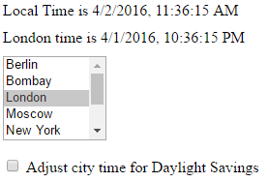

1. C:\Users\drozado\Dropbox\Work\Teaching\IN712 - Web Programming 3\difficultyIcon.png Research online the selectionStart and selectionEnd properties of text fields. Wires up the provided <textarea> tag with an event handler that, when you press F2, inserts the string “Galifianakis” in the text you have selected in the <textarea> element.

